## Problem 3 – Online Shop Form

Create a Web form (HTML5 + CSS3 + images) that looks and behaves like the screenshot below: 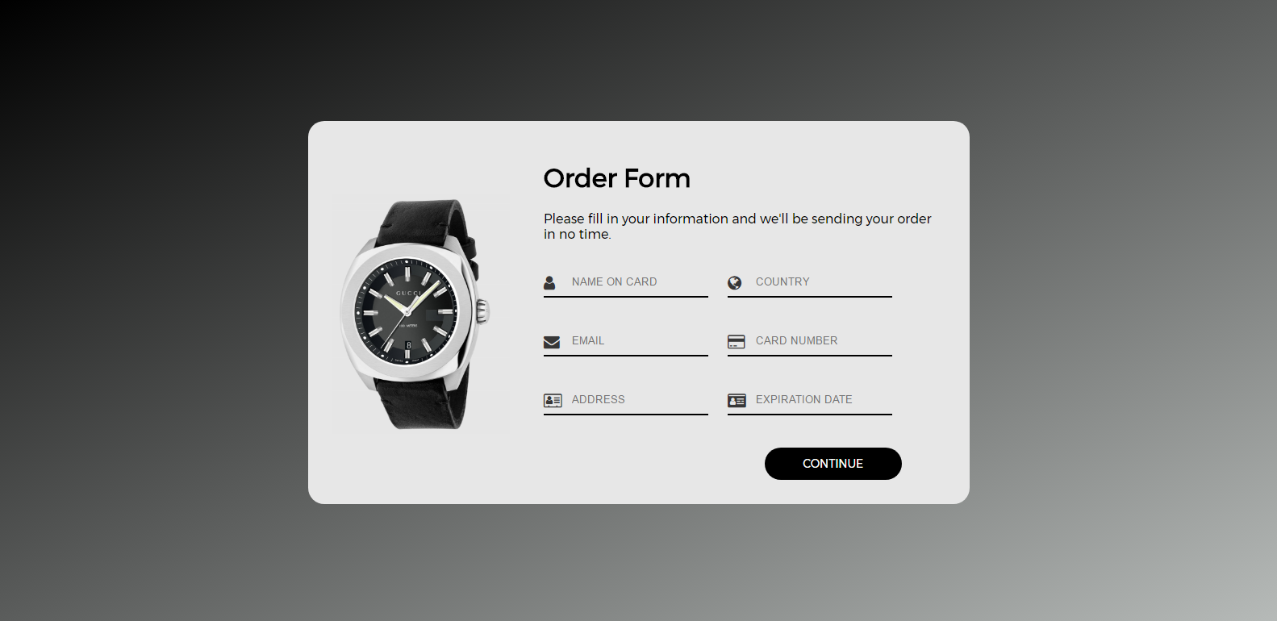

### Input

You are given the above screenshots and all required images.

### Output

The output should be valid HTML5 + CSS3 + images that implement the above Web form.

### Constraints

* Font: **Montserrat** <https://fonts.googleapis.com/css?family=Montserrat>
* Use **Font Awesome** for the icons:

**fa-user**

**fa-globe**

**fa-envelope**

**fa-credit-card  
 fa-address-card-o**

**fa-id-card**

* All fields are text.
* Form validation is not required.
* The site should open correctly in latest version of Chrome.
* Responsive design is not required.
* Pixel-perfect implementation is not required.